Doc Writer: Poornachandra Chejerla Doc Date: January 12, 2015.
Application or System Name
Smart Grid Enablement – Device Lifecycle Management (DM_ENH_700)
General Overview
Business Requirements:
SEFID Route Closure Specialist shall have the ability to determine what the AMCG (Automated Meter Capability Group) setting is within SAP for all smart meters. SEFID Route Closure Specialist shall have the ability to change a smart meter AMCG setting if not in a Blackout period. There shall be the capability for SAP to extract and report the serial number and premise address of Smart Meters cutover to automated reads to be sent Meter Reading Operations (PO Box: Redistricting). There shall be the capability for SAP to extract and report the number of Smart Meters cutover (or not cutover) to automated reads. There shall be the capability for SAP to extract and report the serial number and premise address of Smart Meters not cutover to automated reads to be sent Meter Reading Operations (PO Box: Meter Reading). SEFID Route Closure Specialist shall have the capability to see a list of validated meters in SAP from HE/MDUS. SEFID Route Closure Specialist shall have the capability to review routes under deployment. The report shall by MRU and display the count of meters that are validated in SAP, validated in MDUS, and those ready for cutover. This report shall be able to drill down by meter for a MRU. SEFID Route Closure Specialist shall have the ability to change a smart meter AMCG setting if not in a Blackout period. SEFID Route Closure Specialist shall be able to view multiple MRUs in a table and have the capability to set or remove the AMCG Flag for each device within the MRU. SAP shall extract and report if a meter has been set to a device location (validate the work order has been completed and the new device is in the INST State). Creation of AMI meter profiles shall be automated.

Technical Design:
Program Name : ZDMMRU_EXTRACT_MRU_DATA
T-CODE : ZSECAR01
- Design selection screen which would be displayed on executing the tcode ZSECAR01.
- If user has an authorization for the above Tcode than it would display the screen and based on the inputs given on the screen below data will be fetched.
- Fetch route set , Portion and Meter reading unit from Table ZTDM_SE_CAR_T03
- Where route set and portion route is equal to users input, if data not found than Display an Error message.
- Fetch all the data from table ZTDM_SE_CAR_T01 based on the Selection Screen input of MRU, Division and Device Location, if data not found than Display an Error message.
- Fetch Installation, Date at which time slice expires, Tariff type, Meter reading Unit and Premise from v_eanl where MRU, Date (99991231) and Division is equal to users input.
- Fetch installation, Logical device number and Date at which time slice expires from EASTL based on the installation and Date (99991231)
- Select Equnr, Logiknr, Serial number, Material no, Device location, Division, AMCG group, AMS, Date from v_eger based on the Logiknr and date fetched.
- Select functional location and planning plant from table iflot where Functional location is equal to fetched device location.
- If update radio button is selected than a background job (ZSECAR01) will be created, which would update the table ZTDM_SE_CAR_T01.
  - If the device location already exists in the table then it will update the non-key fields with the new values.
  - If the device location does not exist in the table then the system will create a new entry.
  - Once the background job is completed it will send an email to the user who executed the background job.
- If display radio button is selected then ALV report will be displayed.
- If Cars report radio button is selected then it will execute an background job (ZDMCARS) to produce the report in .CSV format and it will be place in the application server in the appropriate Directory.
- Once the background job is successfully completed an email will be sent.
Program Name : ZDMBL_MANAGE_CARS
T-CODE : ZSECAR04
- Design selection screen which would be displayed on executing the tcode ZSECAR04.
- If user has an authorization for the above Tcode then it would display the screen and based on the inputs given on the screen below data will be fetched.
- Fetch all data from table ZTDM_SE_CAR_T04 where route set number , route set Sort, route set planning, Created date, status, cut over date, creation date, Cutover date is equal to the selection screen inputs given by the user.
- Fetch all the data from the table ZTDM_SE_CAR_T03 where route set is equal the Route set value which is fetched in the above select query.
- Select MRU from table TE422 where MRU is equal to the selection screen Input.
- Fetch all data from table ZTDM_SE_CAR_T01 based on the MRU fetched in the previous Query.
- Fetch all data from table ZTDM_SE_CAR_T05 based on the MRU.
- Fetch all the data from ZTDM_SE_CAR_T02 and ZTDM_SE_CAR_T06 based on the device location fetched in the previous query.
- If data not found then raise an Error message.
- At the time of remote meter read capability assignment to the meter, if the meter qualifies for interval billing enablement, additional steps will be performed in the background for interval assignment, profile creation and profile allocation.

- The EDM profile creation and allocation will be performed through a separate function module Z_REG_AMCG_PROFILE_UPDATE
- The Z_REG_AMCG_PROFILE_UPDATE function module will determine if the meter is eligible to be cutover for register billing or interval billing from the ZTCC_BILINS_ELEC Bill install table.
- If eligible for interval billing, will perform register modification using the bill install table as reference.
- Device modification is performed and appropriate register values updated to the meter with the help of function modules 'ISU_S_DEVICEMOD_PROVIDE' and 'ISU_S_DEVICEMOD_CHANGE'
- Bill factor details and device relationships for device is updated to the meter using function modules 'ISU_S_DEVICEREL_PROVIDE’ and ‘ISU_S_DEVICEREL_CHANGE’.
- If there is an interval register assigned to the meter, a corresponding EDM profile will be created and allocated.
- By default, the day after the last billing date of the device will be used as the activity date for device modification, profile creation and profile allocation.
- Creates EDM profile for post cut over max demand with function module 'ISU_S_PROFHEAD_CREATE'
- The created profile need to be allocated to installation and to interval register of device. Perform profile allocation for new installation for the new device with the available start date and with the end date 12/31/9999. This will be done by function module 'ISU_S_PROFASS_CHANGE’.

- The system displays the Function and Data Selection Screen once executing the report, Screen Area 1 is for Route Set Selection fields and Screen Area 2 is for MRU selection fields.

System Diagram
☐ Selection screen that’s presented to user
Tcode: ZSECAR01
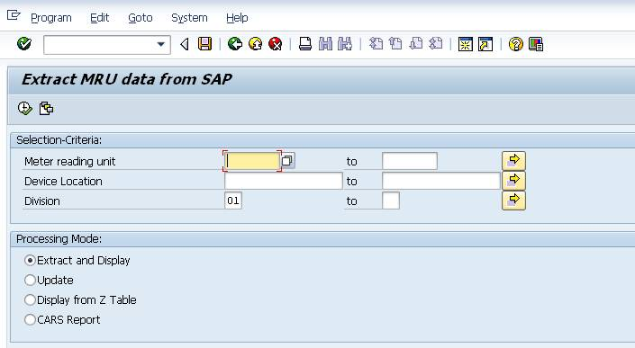

Tcode: ZSECAR04
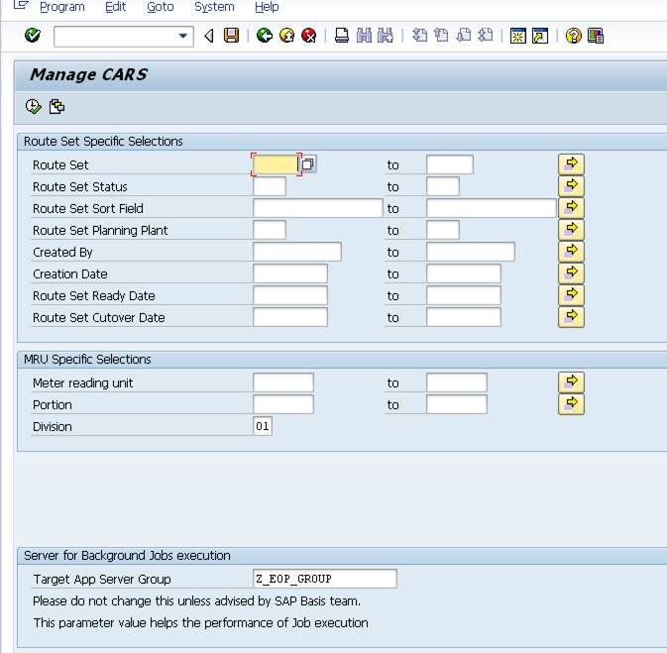

Technical Parts Inventory
-------Name------- | --Description-- | --Location-- | -Environment--
ZDMMRU_EXTRACT_MRU_DATA | REPORT |  | E2D
ZSECAR01 | TCODE |  | E2D
ZTDM_SE_CAR_T01 | TABLE |  | E2D
ZTDM_SE_CAR_T02 | TABLE |  | E2D
ZTDM_SE_CAR_T03 | TABLE |  | E2D
ZTDM_SE_CAR_T04 | TABLE |  | E2D
ZSECAR04 | TCODE |  | E2D
ZDMBL_MANAGE_CARS | REPORT |  | E2D
ZDMBL_CARS_CHANGE_AMCG | REPORT |  | E2D
Z_REG_AMCG_PROFILE_UPDATE | FUNCTIONMODULE |  | E2D

Dependent Parts Inventory
-------Name------- | ----Description--- | -----Location----- | ----Environment---

Security Roles and AD Group Needed to Run App

